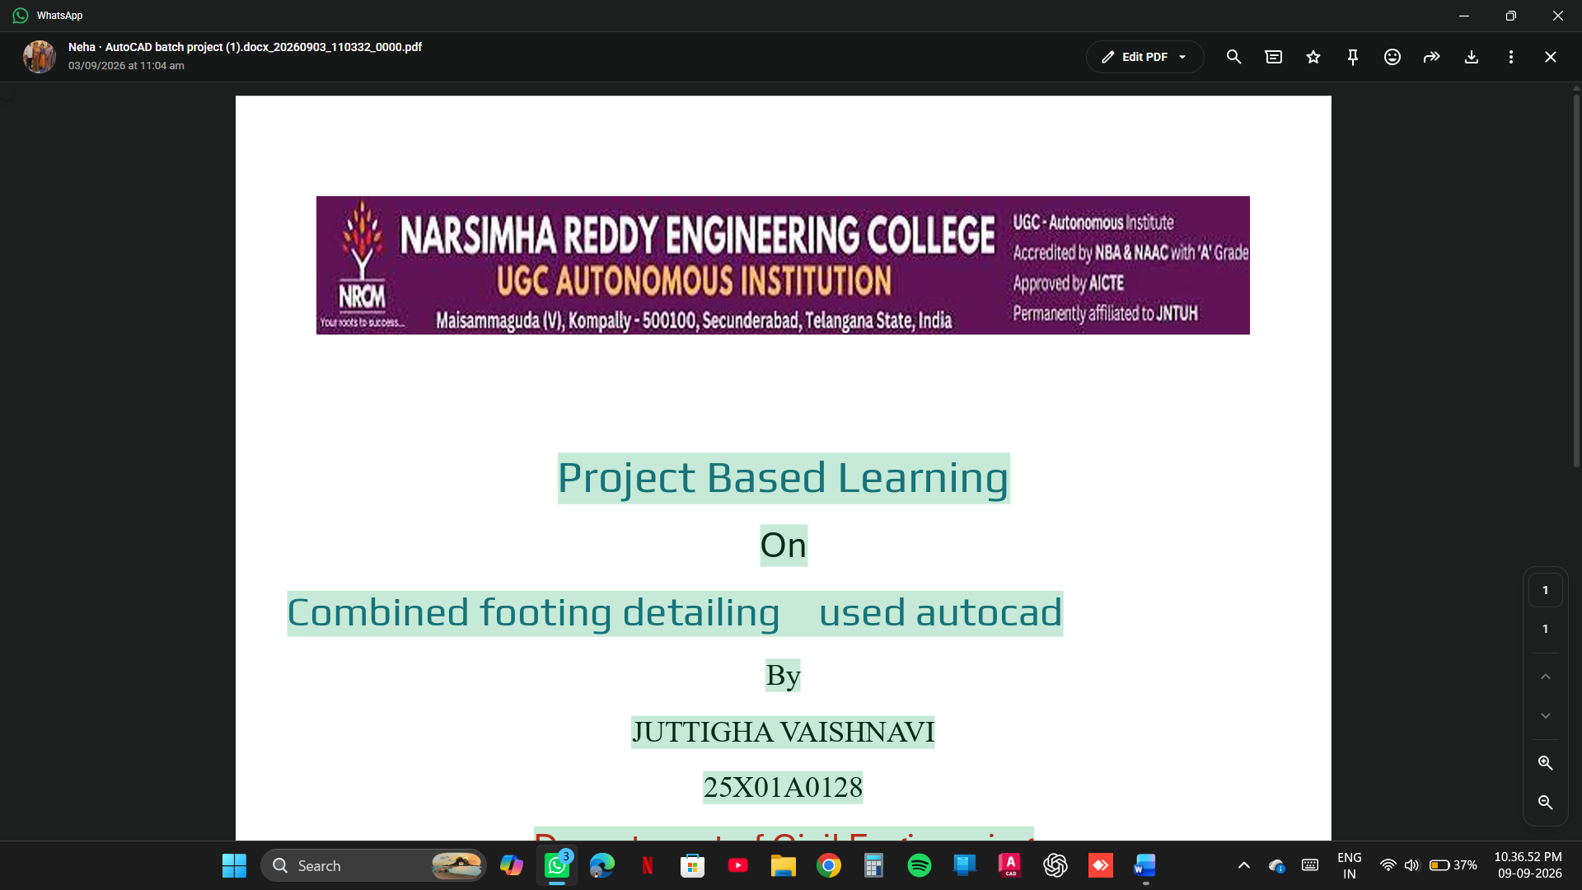
PROJECT BASED LEARNING
ON

ISOLATED AND COMBING FOOTING DESIGN AND DRAFTING BY USING AUTO CAD

BY

BOOBALI NEHA 25X01A0107

DEPARTMENT OF CIVIL ENGINEERING

NARSIMHA REDDY ENGINEERING COLLEGE (UGC- AUTONOMOUS) APPROVED BY AICTE, AFFILIATED TO JNTUH, ACCREDITED BY NBA & NAAC WITH A-GRADE)
MAISAMMAGUDA (V), KOMPALLY, SECUNDERABAD,500100.(20262027)
COMPUTER AIDED DRAFTING SOFTWARE PROJECT

ISOLATED AND COMBING FOOTING DESIGN AND DRAFTING BY USING AUTOCAD

Project Report

ON

ISOLATED AND COMBING FOOTING

Civil Engineering – Computer Aided Drafting
Narsimha Reddy Engineering College (NRCM)

1. INTRODUCTION
Footings are important structural components of a building that transfer the loads from columns to the soil safely. They distribute the structural loads over a larger area to prevent excessive settlement and failure of the foundation.
An isolated footing is a type of shallow foundation provided below a single column. It is generally used when columns are spaced sufficiently far apart and the soil has adequate bearing capacity.
A combined footing is a foundation that supports two or more columns on a single concrete base. It is generally adopted when columns are closely spaced or when an isolated footing cannot be provided due to property boundaries or limited space.
The design of isolated and combined footings involves calculating the required dimensions, soil pressure, bending moments, shear forces and reinforcement details.
AutoCAD is used for drafting the footing plans, cross-sections, reinforcement details and structural dimensions accurately. It helps civil engineers prepare clear and professional structural drawings.
2. PROBLEM STATEMENT
In building construction, proper foundation design is essential to ensure the safety, stability and durability of structures. Improper footing design may cause excessive settlement, cracks and structural failure.
Designing isolated and combined footings manually can be time-consuming and may lead to drafting errors.
Therefore, this project focuses on designing isolated and combined footings based on structural requirements and preparing detailed drawings using AutoCAD.
The project aims to provide accurate footing dimensions, reinforcement arrangements and construction details while ensuring safe load transfer from columns to the soil.
3. OBJECTIVES
The main objectives of this project are:
- To understand the basic concepts of isolated and combined footings.
- To study the importance of foundations in building construction.
- To calculate the dimensions of isolated and combined footings.
- To determine the soil bearing pressure and footing area.
- To calculate bending moments and shear forces.
- To design suitable reinforcement for both types of footings.
- To prepare detailed footing drawings using AutoCAD.
- To develop plan and sectional views with proper dimensions.
- To improve drafting accuracy and technical drawing skills.
- To understand the practical applications of footing design in civil engineering.
4. PROPOSED METHODOLOGY
The project is carried out through the following steps:
Step 1: Collection of Data
Collect the required structural information, including:
- Column loads.
- Column dimensions.
- Safe bearing capacity of soil.
- Grade of concrete.
- Grade of steel.
- Soil and site conditions.
Step 2: Selection of Footing Type
Select the suitable footing based on column spacing, loading conditions and soil bearing capacity.
- Isolated footing for individual columns.
- Combined footing for two or more columns.
Step 3: Design of Isolated Footing
- Calculate the total load acting on the column.
- Determine the required footing area.
- Calculate the length, width and depth.
- Check soil pressure.
- Calculate bending moment and shear force.
- Design reinforcement according to structural requirements.
Step 4: Design of Combined Footing
- Determine the loads acting on both columns.
- Calculate the total footing area.
- Locate the resultant of column loads.
- Determine suitable footing dimensions.
- Calculate soil pressure distribution.
- Check bending moment and shear force.
- Design the required reinforcement.
Step 5: AutoCAD Drafting
Prepare the structural drawings using AutoCAD.
The following drawings are prepared:
- Isolated footing plan.
- Isolated footing cross-section.
- Combined footing plan.
- Combined footing cross-section.
- Reinforcement detailing.
- Column and footing dimensions.
Step 6: Dimensioning and Final Drawing
- Apply suitable dimensions.
- Use different layers for reinforcement, concrete and columns.
- Add annotations and labels.
- Check drawing accuracy.
- Prepare the final drawing and export it into PDF format.
5. RESULTS
The project successfully demonstrates the design and drafting of isolated and combined footings using AutoCAD.
The following results are obtained:
- Isolated footing dimensions are calculated based on column loads and soil bearing capacity.
- Combined footing dimensions are determined based on the loads from multiple columns.
- Soil pressure is checked to ensure safe load transfer.
- Required reinforcement details are prepared.
- Plan and sectional views are drafted using AutoCAD.
- Accurate dimensions and annotations are added to the drawings.
- Final structural drawings are prepared for construction reference.
The project provides a clear understanding of the differences between isolated and combined footing designs.
6. OUTCOMES
After completing this project, the following outcomes are achieved:
- Gained knowledge about isolated and combined footing design.
- Understood the importance of safe foundation design.
- Learned how to calculate footing dimensions.
- Understood soil pressure distribution and load transfer mechanisms.
- Developed knowledge of reinforcement detailing.
- Improved practical skills in AutoCAD drafting.
- Learned to prepare plan and sectional drawings.
- Understood the application of structural design principles in building construction.
- Improved technical drawing and interpretation skills.
- Gained practical knowledge useful for civil engineering projects.
COMINED FOOTING
Top View

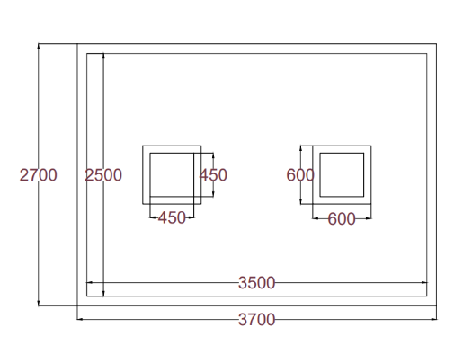

Side View

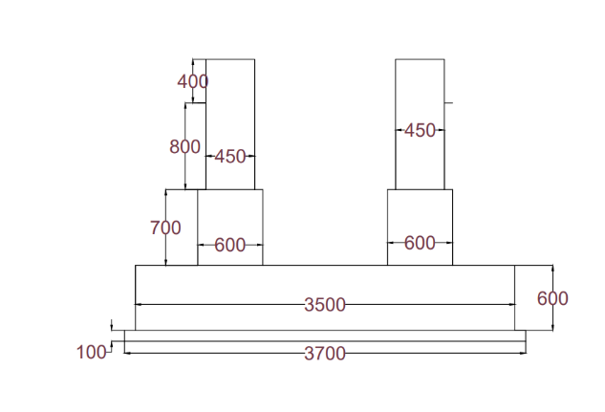
ISOLATED FOOTING
TOP VIEW
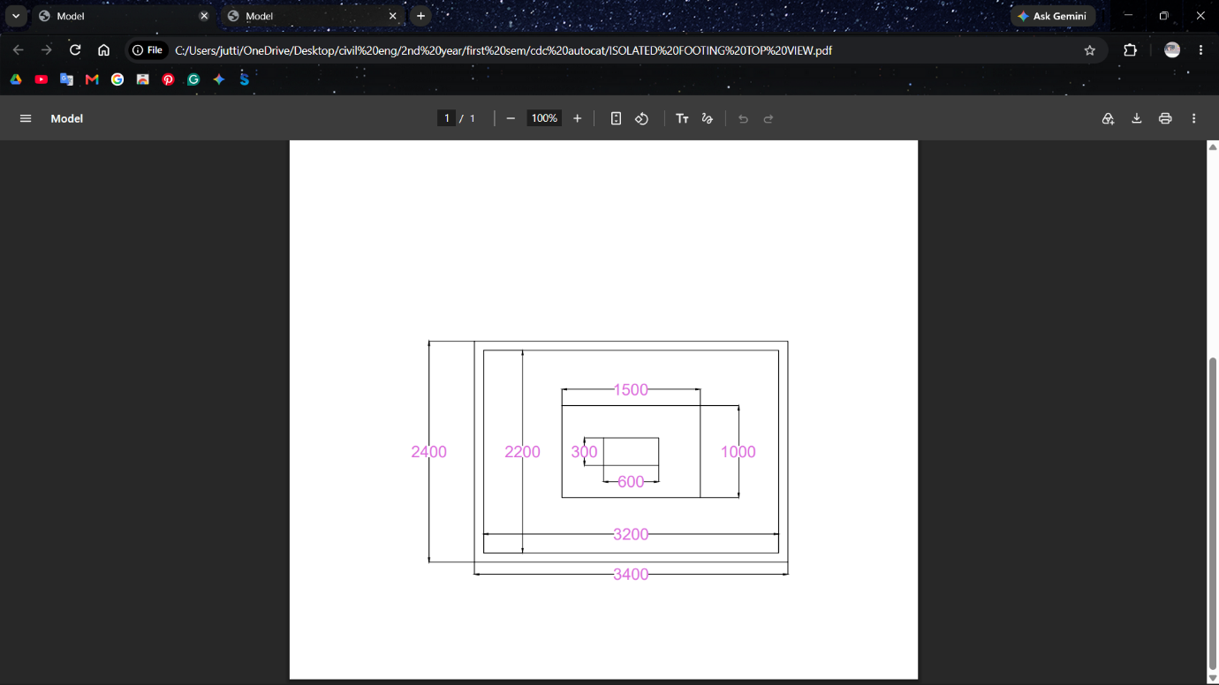
SIDE VIEW
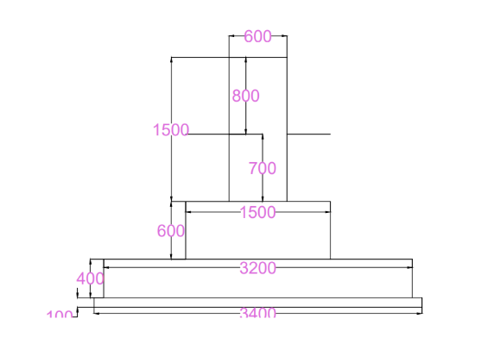
7. CONCLUSION
The project on Isolated and Combined Footing Design and Drafting Using AutoCAD provides a clear understanding of foundation design and structural detailing.
Both isolated and combined footings play an important role in transferring building loads safely to the ground. The design process involves calculating footing dimensions, checking soil pressure, determining bending moments and shear forces, and providing suitable reinforcement.
AutoCAD helps prepare accurate and detailed structural drawings with proper dimensions, annotations and reinforcement arrangements.
This project improves practical knowledge of foundation engineering and develops technical skills in computer-aided drafting. It also helps understand the importance of proper footing design in ensuring the safety, stability and durability of buildings.
8. REFERENCES
- B.C. Punmia, Ashok Kumar Jain and Arun Kumar Jain, Soil Mechanics and Foundations, Laxmi Publications.
- S. Ramamrutham, Design of Reinforced Concrete Structures, Dhanpat Rai Publishing Company.
- IS 456:2000 – Plain and Reinforced Concrete – Code of Practice.
- IS 1904:2021 – General Requirements for Design and Construction of Foundations in Soils.
- IS 6403:1981 – Code of Practice for Determination of Bearing Capacity of Shallow Foundations.
- Autodesk, AutoCAD User Guide and Documentation.
- Relevant civil engineering textbooks, class notes and structural design manuals.

COMINED FOOTING
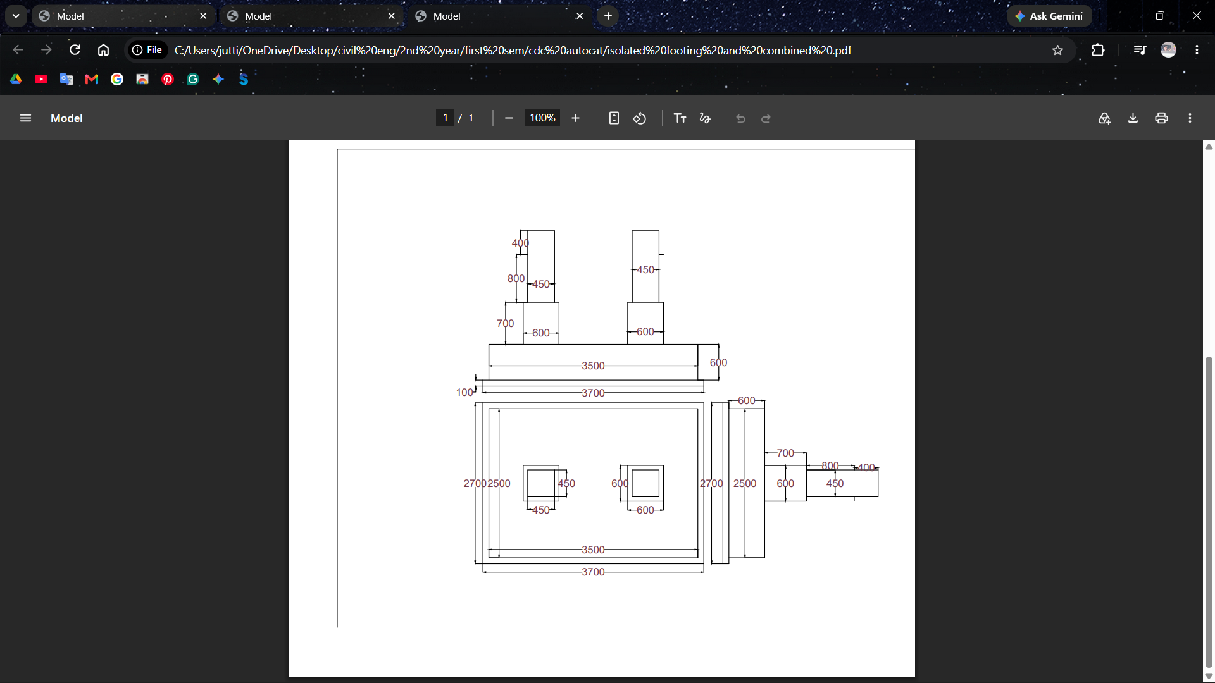

ISOLATED FOOTING



